LAB # 14

Introduction to GitHub

OBJECTIVE
Introduction to GitHub by creating Git repository and cloning its configuration to eclipse project.

Lab Task:
Create account on GitHub.
Upload any of your Java Project files and perform commit, push, pull and merge operations.
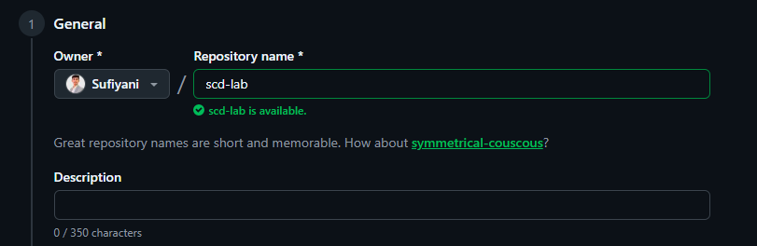
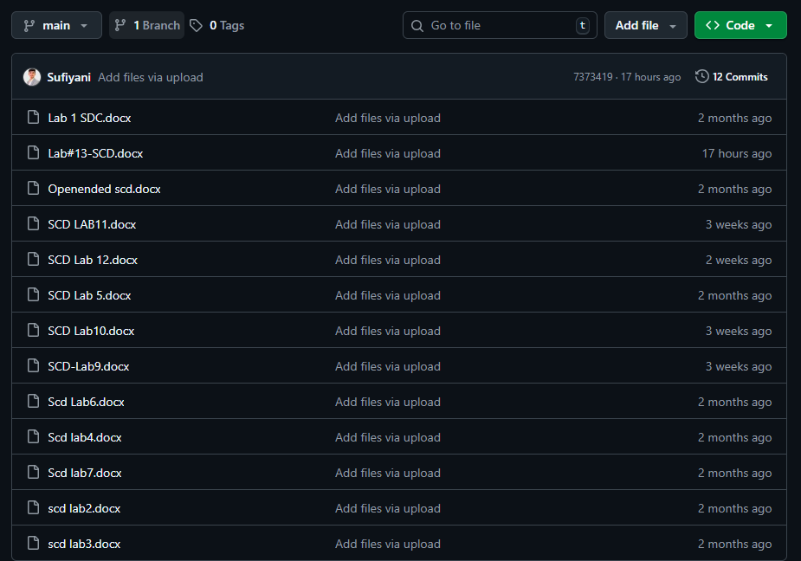
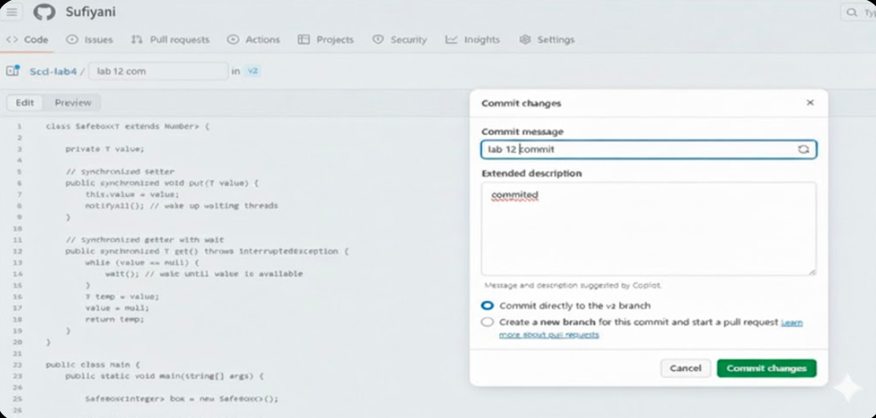
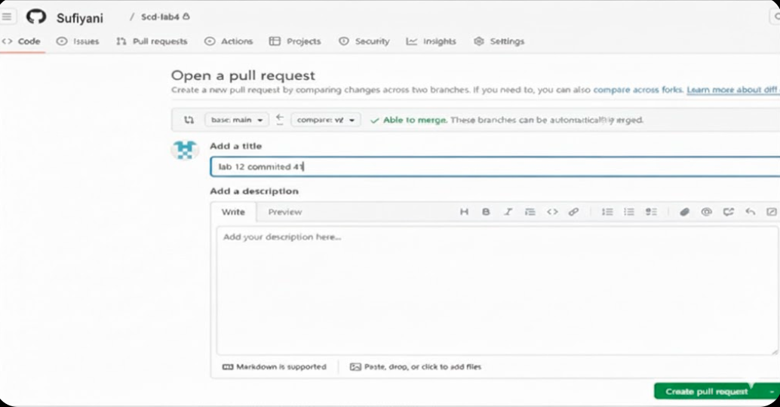
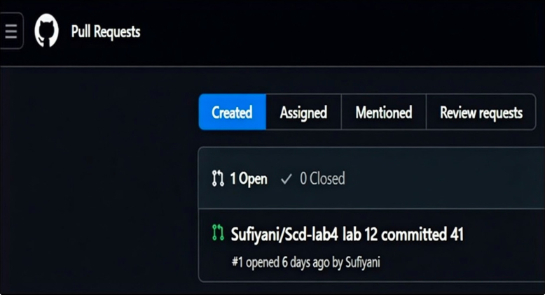
Github Screenshot:
